**HP LOAD RUNNER UP**

**MODULE 4**

1. **Which components have you used in Load Runner?**

The key components of LoadRunner are:

1. Vuser generator – For generating Scripts

2. Controller – For creating and executing scenarios

3. Analyzer – To analyze results.

1. **How can you set the number of Vusers in Load Runner?**

In the Vusers dialog box, click the Add Vuser(s)button. The Add Vusers dialog box opens. From the Quantity to add box, select the number of Vusers that you want to add to the group.

1. **What is Correlation?**

Correlation is used to obtain data that is unique for each run of your test script (ex: session ids). While recording, these dynamic values are hard-coded in your script causing the script to fail during playback. Correlation is a technique where dynamic values are not hard-coded in your script but are extracted at run-time to avoid failure.

1. **What is the process for developing a Vuser Script?**

There are four steps for developing a vuser script.

1. Record the Vuser Script.
2. Playback / Enhance the recorded vuser script.
3. Define the various run-time settings & check.
4. Incorporate the script in a LoadRunner scenario.
5. **How Load Runner interacts with the application?**

LoadRunner simulates user activity by generating messages between application components or by simulating interactions with the user interface such as keypresses or mouse movements. The messages and interactions to be generated are stored in scripts.

1. **How many VUsers are required for load testing?**

The number of VUsers required depends on your system under test, network configurations, hardware settings, memory, operating system, and software applications objective of a performance test. There can not be any generic value for Vuser

1. **What is the relationship between Response Time and Throughput?**

The Throughput graph shows the amount of data in bytes that the Vusers received from the server in a second. When we compare this with the transaction response time, we will notice that as throughput decreased, the response time also decreased. Similarly, the peak throughput and highest response time would occur approximately at the same time.

1. **What is the difference between hits/second and requests/second?**

• Hits per second means the number of hits the server receives in one second from the vuser

• Request per second is the number of requests the vuser will request from the server.

1. **Create a normal script of the below website with a correlate using hp default website.**

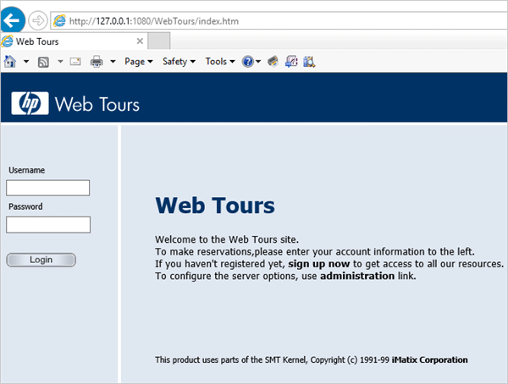

**LoadRunner VuGen Script Recording, Replay, and Handling Dynamic Values with Correlation Technique:**

Script Recording: In the **Script Section**, we discussed three sections of the script (vuser_init, Action, vuser_end) and the running sequence.

On **New Virtual User Dialog**, we try to touch base with all the fields and their importance so that while selecting the protocol for scripting, the user should know its significance. This is the first step for script creation. VuGen proviant des option to create **Single Protocol** and **Multiple** **Protocol** scripts.

On **Start Recording Dialog**, we discussed the fields with their valid input data. This is the second step for script creation. From this dialog type of application, browser, URL, working directory, and “Record into Action” options are selected.

In the **Recording Option**, we covered the following topics in detail:

1. Scripts

2. Protocol

3. Recording

4. Port Mapping

5. Advanced Settings

6. Correlation

7. Code Generation.

**Script** – This provides an option to select the scripting language along with a few settings related to the script. For Web (HTTP/HTML) protocol, the scripting language is C.

**Protocol** – This displays the protocol that we selected on New Virtual User Dialog box.

**Zip file Link with GitHub portal:** https://github.com/sakeesaurab9/Saket-Testing

1. https://github.com/sakeesaurab9/Saket-Testing/blob/main/Scenario1.rar

2. https://github.com/sakeesaurab9/Saket-Testing/blob/main/Session1.rar

3. https://github.com/sakeesaurab9/Saket-Testing/blob/main/WebHttpHtml1.rar (script)